Seif Soltan - 202511598

System Class Specifications
Detailed breakdown of purpose, attributes, associations, and multiplicity for all system classes.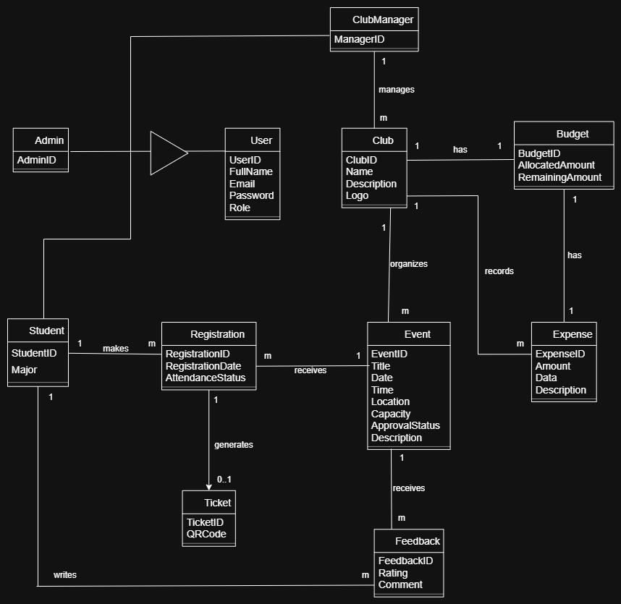
1. User Class
Class Name | User
Purpose | Represents a general user in the system with credentials and system roles.
Attributes | UserID, FullName, Email, Password, Role
Associations | Admin, Student
Multiplicity | Superclass for Admin and Student (Generalization/Inheritance relationship).

2. Admin Class
Class Name | Admin
Purpose | Represents an administrator user who manages the entire system platform.
Attributes | AdminID
Associations | User
Multiplicity | Inherits from User class (Generalization).

3. Student Class
Class Name | Student
Purpose | Represents a student user who can register for events and submit feedback.
Attributes | StudentID, Major
Associations | User, Registration, Feedback
Multiplicity | One Student can make multiple Registrations (1 to m) and write multiple Feedbacks (1 to m).

4. ClubManager Class
Class Name | ClubManager
Purpose | Represents the manager responsible for overseeing and operating student clubs.
Attributes | ManagerID
Associations | Club
Multiplicity | One ClubManager manages multiple Clubs (1 to m).

5. Club Class
Class Name | Club
Purpose | Represents a student organization on campus that organizes events and manages budgets.
Attributes | ClubID, Name, Description, Logo
Associations | ClubManager, Event, Budget, Expense
Multiplicity | Managed by m Managers, organizes multiple Events (1 to m), has one Budget (1 to 1), and records multiple Expenses (1 to m).

6. Budget Class
Class Name | Budget
Purpose | Tracks and holds the financial budget allocated to a specific club.
Attributes | BudgetID, AllocatedAmount, RemainingAmount
Associations | Club, Expense
Multiplicity | One Club has one Budget (1 to 1), and one Budget has multiple Expenses (1 to m).

7. Expense Class
Class Name | Expense
Purpose | Represents financial expenditure incurred by a club.
Attributes | ExpenseID, Amount, Data, Description
Associations | Budget, Club
Multiplicity | Multiple Expenses belong to one Budget (m to 1) and are recorded by one Club (m to 1).

8. Event Class
Class Name | Event
Purpose | Represents a campus event organized by a student club.
Attributes | EventID, Title, Date, Time, Location, Capacity, ApprovalStatus, Description
Associations | Club, Registration, Feedback
Multiplicity | Organized by one Club (1 to m), receives multiple Registrations (1 to m), and receives multiple Feedbacks (1 to m).

9. Registration Class
Class Name | Registration
Purpose | Manages the event enrollment record created when a student registers for an event.
Attributes | RegistrationID, RegistrationDate, AttendanceStatus
Associations | Student, Event, Ticket
Multiplicity | Made by one Student (m to 1), belongs to one Event (m to 1), and generates zero or one Ticket (1 to 0..1).

10. Ticket Class
Class Name | Ticket
Purpose | Represents an entrance pass generated for a valid registration.
Attributes | TicketID, QRCode
Associations | Registration
Multiplicity | Generated from zero or one Registration (0..1 to 1).

11. Feedback Class
Class Name | Feedback
Purpose | Represents review comments and ratings submitted by students for an event.
Attributes | FeedbackID, Rating, Comment
Associations | Student, Event
Multiplicity | Written by one Student (m to 1) and received by one Event (m to 1).

